ILLINOIS POLLUTION CONTROL BOARD
September 1, 2005

IN THE MATTER OF: )
)
WASTEWATER PRETREATMENT ) R06-2
UPDATE, USEPA REGULATIONS ) (Identical-in-Substance
(January 1, 2005 through June 30, 2005) ) Rulemaking - Land)

Proposed rule. Dismissal order.

ORDER OF THE BOARD (by J.P. Novak):

Sections 7.2 and 13.3 of the Environmental Protection Act (Act) (415 ILCS 5/7.2 and 13.3 (2004)), require the Board to adopt regulations that are “identical in substance” to regulations of the United States Environmental Protection Agency (USEPA). 415 ILCS 5/7.2 (2004). Specifically, Section 13.3 relates to wastewater pretreatment regulations that the USEPA adopted to implement Sections 307(b), (c), and (d) and 402(b)(8) and (b)(9) of the federal Water Pollution Control Act (FWPCA) (33 U.S.C. §§ 1317(b), (c), and (d) and 1342(b)(8) and (b)(9) (2003)). USEPA has codified the federal wastewater pretreatment rules as 40 C.F.R. 400 through 499.

The Board reserved this docket for any wastewater pretreatment amendments adopted by USEPA between January 1, 2005 through June 30, 2005. During that time period, USEPA amended the federal wastewater pretreatment regulations once, on February 1, 2005 (at 70 Fed. Reg. 5058). The Board consolidated and adopted those amendments in the wastewater pretreatment docket, Wastewater Pretreatment Update, USEPA Amendments (January 1, 2004 through June 30, 2004), R05-4, and Wastewater Pretreatment Update, USEPA Amendments (July 1, 2004 through December 31, 2004, February 1, 2005), R05-15 (Apr. 21, 2005) (consolidated). Therefore, no action is necessary, and the Board dismisses this docket.

IT IS SO ORDERED.

I, Dorothy M. Gunn, Clerk of the Illinois Pollution Control Board, certify that the above order was adopted on September 1, 2005, by a vote of 5-0.

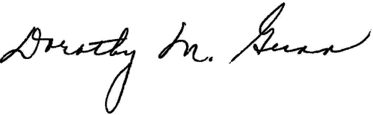
Dorothy M. Gunn, Clerk
Illinois Pollution Control Board

