title 2: governmental organization

subtitle e: MISCELLANEOUS state agencies

CHAPTER XIV: ENVIRONMENTAL PROTECTION AGENCY

PART 1825

PUBLIC INFORMATION, RULEMAKING AND ORGANIZATION

SUBPART A: PUBLIC INFORMATION
Section
1825.10 Access to Information of the Illinois Environmental Protection Agency
1825.20 Procedures for Determining and Protecting Confidential Information

SUBPART B: RULEMAKING
Section
1825.30 Applicability
1825.40 Definitions
1825.50 Procedure
1825.60 Public Hearings

SUBPART C: ORGANIZATION
Section
1825.70 Applicability
1825.80 Definitions
1825.90 Agency Organization

Appendix A Organization Chart of the Environmental Protection Agency State of Illinois Part One
Appendix B Organization Chart of the Environmental Protection Agency State of Illinois Part Two

AUTHORITY: Implementing Section 4.01 of the Illinois Administrative Procedure Act (Ill. Rev. Stat. 1983, ch. 127, par. 1004.01) and authorized by Section 4 of the Environmental Protection Act (Ill. Rev. Stat. 1983, ch. 111 ½, par. 1004).

SOURCE: Adopted at 8 Ill. Reg. 23202, effective November 30, 1984.

SUBPART A: PUBLIC INFORMATION

Section 1825.10 Access to Information of the Illinois Environmental Protection Agency
The Illinois Environmental Protection Agency’s (Agency) policy concerning public access to Agency information is contained in the Agency’s rules “Access to Information of the Illinois Environmental Protection Agency” (35 Ill. Adm. Code 160), filed with the Secretary of State, Administrative Code Unit on June 19, 1984.

Section 1825.20 Procedures for Determining and Protecting Confidential Information
The Agency’s policy concerning the determination and protection of confidential information is contained in “Procedures for Determining and Protecting Confidential Information” (35 Ill. Adm. Code 161), filed with the Secretary of State, Administrative Code Unit on June 20, 1984.

SUBPART B: RULEMAKING

Section 1825.30 Applicability
This subpart applies to all divisions within the Illinois Environmental Protection Agency.

Section 1825.40 Definitions
Statutory definitions shall apply to terms in Agency rules, unless otherwise defined.

Section 1825.50 Procedure
- Rules may be proposed by the Director or Agency’s divisions. Final adopted rules shall only be approved by the Director.
- Any interested person may petition the Director to make, amend or repeal an Agency rule.
  - The petition shall be addressed to:

Director
Illinois Environmental Protection Agency
2200 Churchill Road
Springfield, Illinois 62706

  - The petition shall contain a clear statement of reasons for the proposed rule, amendment or repeal and the exact language of the suggested new rule or amendment.
- The principal copy of the Agency’s adopted rules which have been filed with the Secretary of State Administrative Code Unit (ACU) and stamped by the ACU with the date the rules were filed, shall be kept at the Agency’s Library at 2200 Churchill Road, Springfield, Illinois; other stamped copies shall be kept at the Agency’s divisional regional offices, and shall be available for public review from 8:30 am to 4:30 pm during State working days.
- In proposing and adopting rules the Agency shall follow the requirements of the Illinois Administrative Procedure Act (Ill. Rev. Stat. 1983, ch. 127, par. 1001-1 et seq.); the rules of the Joint Committee on Administrative Rules (1 Ill. Adm. Code 220, 230 and 240); the Secretary of States “Rulemaking Procedures” (1 Ill. Adm. Code 100), and the Secretary of State’s “Administrative Code Style Manual”.

Section 1825.60 Public Hearings
Public hearings required under Section 5.01(a)(5) of the Illinois Administrative Procedure Act (Ill. Rev. Stat. 1983, ch. 127, par. 1005.01(a)(5)) shall be held in accordance with the Agency’s “Procedures for Informational and Quasi-Legislative Public Hearings” (35 Ill. Adm. Code 164).

SUBPART C: ORGANIZATION

Section 1825.70 Applicability
This Part applies to all divisions and sections within the Illinois Environmental Protection Agency.

Section 1825.80 Definitions
“Agency” means Illinois Environmental Protection Agency.

“Division” means a unit of the Agency, responsible for carrying out certain administrative duties, functions and policies and managed by a Divisional Manager.

Section 1825.90 Agency Organization
- The organization and duties of the Agency staff are established by the Director, as provided by Section 4 of the Environmental Protection Act (Ill. Rev. Stat. 1983, ch. 111 ½, par. 1004).
- The organization of the Agency is illustrated in the organization charts in Appendices A and B, or as hereafter amended.

Appendix A Organization Chart Environmental Protection Agency

State of Illinois Part One
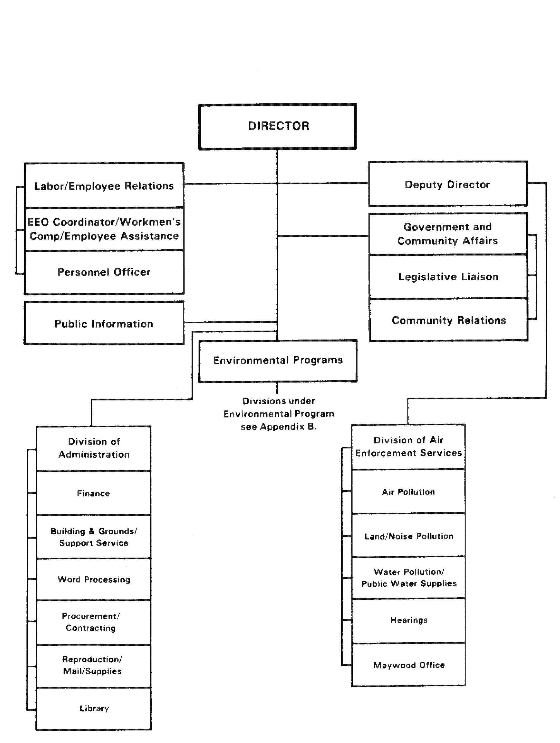

Appendix B Organization Chart Environmental Protection Agency

State of Illinois Part-Two

