ILLINOIS POLLUTION CONTROL BOARD
February 3, 2005

IN THE MATTER OF: )
)
SDWA UPDATE, USEPA AMENDMENTS ) R05-17
(July 1, 2004 through December 31, 2004) ) (Identical-in-Substance Rulemaking -
) Public Water Supply)

Proposed rule. Dismissal order.

ORDER OF THE BOARD (by G.T. Girard):

Section 17.5 of the Environmental Protection Act (Act) (415 ILCS 5/17.5 (1998)) requires the Board to adopt regulations that are “identical in substance,” as defined at Section 7.2 of the Act, to the National Primary Drinking Water regulations (NPDWRs) adopted by the United States Environmental Protection Agency (USEPA). These regulations implement sections 1412(b), 1414(c), 1417(a), and 1445(a) of the Safe Drinking Water Act (SDWA), 42 U.S.C. §§ 300g-1(b), 300g-3(c), 300g-6(a) & 300j-4(a) (1998). USEPA has codified its SDWA regulations at 40 C.F.R. 141 through 143. The Board reserved this docket for any SDWA amendments adopted by USEPA between July 1, 2004 through December 31, 2004.

During that time period, USEPA amended its SDWA regulations once, in two actions, on August 25, 2004 (at 69 Fed. Reg. 52176 and 52181). On that date, USEPA withdrew a direct final rule it had adopted on June 2, 2004 (69 Fed. Reg. 31008), then simultaneously adopted amendments identical to those withdrawn. The Board included the August 25, 2004 federal amendments in the prior update docket, SDWA Update, USEPA amendments (July 1, 2004 through December 31, 2004) R05-6 (Jan. 20, 2005). Thus, no Board action is required based on the August 25, 2004 federal amendments in this reserved update docket.

For the foregoing reasons, the Board hereby dismisses this docket.

IT IS SO ORDERED.

I, Dorothy M. Gunn, Clerk of the Illinois Pollution Control Board, certify that the above order was adopted on February 3, 2005, by a vote of 4-0.
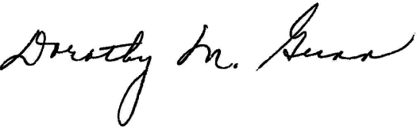
Dorothy M. Gunn, Clerk
Illinois Pollution Control Board

