ILLINOIS POLLUTION CONTROL BOARD
February 3, 2005

IN THE MATTER OF: )
)
RCRA SUBTITLE D UPDATE, USEPA ) R05-12
REGULATIONS (July 1, 2004 through ) (Identical-in-Substance
December 31, 2004) ) Rulemaking - Land)

Proposed rule. Dismissal order.

ORDER OF THE BOARD (by G.T. Girard):

Section 22.40(a) of the Environmental Protection Act (Act) (415 ILCS 5/22.40(a) (2002)) requires the Board to adopt regulations that are “identical in substance” to regulations of the United States Environmental Protection Agency (USEPA). 415 ILCS 5/7.2 (2002). Specifically, Section 22.40(a) relates to municipal solid waste landfill (MSWLF) regulations that USEPA adopted to implement Subtitle D of the Resource Conservation and Recovery Act of 1976 (42 U.S.C §§ 6941-6949 (1998); RCRA Subtitle D). USEPA has codified the federal MSWLF rules as 40 C.F.R. 258.

The Board reserved this docket for USEPA amendments during the period between July 1, 2004 through December 31, 2004. During that time period, USEPA did not amend its MSWLF regulations. Therefore, no action is necessary, and the Board dismisses this docket.

IT IS SO ORDERED.

I, Dorothy M. Gunn, Clerk of the Illinois Pollution Control Board, certify that the Board adopted the above order on February 3, 2005, by a vote of 4-0.
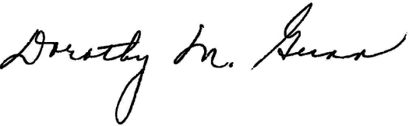
Dorothy M. Gunn, Clerk
Illinois Pollution Control Board

