ILLINOIS POLLUTION CONTROL BOARD
July 26, 2018
IN THE MATTER OF:  DEFINITION OF VOM UPDATE, USEPA REGULATIONS (January 1, 2018 through June 30, 2018) | )  )  )  )  ) | R19-7  (Identical-in-Substance Rulemaking - Air)
Proposed rule. Dismissal order.
ORDER OF THE BOARD (by U. Choe):
Section 9.1(e) of the Environmental Protection Act (Act) (415 ILCS 5/9.1(e) (2016)) requires the Board to adopt regulations that are “identical in substance” to regulations of the United States Environmental Protection Agency (USEPA). 415 ILCS 5/7.2 (2016). Specifically, Section 9.1(e) of the Act (415 ILCS 5/9.1(e) (2016)) relates to the definition of “volatile organic material” (VOM) and those compounds that USEPA has found to be exempted from regulation under state implementation plans for ozone due to negligible photochemical reactivity. USEPA has codified these exemptions as part of its definitions at 40 C.F.R. 51.100(s).
The Board reserved this docket for USEPA amendments to the definition of VOM that occurred during the period between January 1, 2018 through June 30, 2018. During that period, USEPA did not amend its definition of VOM. Therefore, no action is necessary, and the Board dismisses this docket.
IT IS SO ORDERED.
I, Don A. Brown, Clerk of the Illinois Pollution Control Board, certify that the Board adopted the above order on July 26, 2018, by a vote of 5-0.
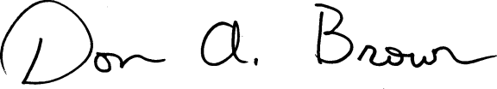
Don A. Brown, Clerk
Illinois Pollution Control Board

