ILLINOIS POLLUTION CONTROL BOARD
May 18, 2006

IN THE MATTER OF: )
)
EXEMPTIONS FROM THE ) R06-14
DEFINITION OF VOM UPDATE, ) (Identical-in-Substance
USEPA REGULATIONS (July 1, 2005 ) Rulemaking - Air)
through December 31, 2005) )

Proposed rule. Dismissal order.

ORDER OF THE BOARD (by G.T. Girard):

Section 9.1(e) of the Environmental Protection Act (415 ILCS 5/9.1(e) (2004)) requires the Board to adopt regulations that are “identical in substance” to regulations of the United States Environmental Protection Agency (USEPA). 415 ILCS 5/7.2 (2004). Specifically, Section 9.1(e) of the Act (415 ILCS 5/9.1(e) (2002)) relates to the definition of “volatile organic material” (VOM) and those compounds that USEPA has found to be exempted from regulation under state implementation plans for ozone due to negligible photochemical reactivity. USEPA has codified these exemptions as part of its definitions at 40 C.F.R. 51.100(s).

The Board reserved this docket for USEPA amendments to the definition of VOM that occurred during the period between July 1, 2005 through December 31, 2005. During that time period, USEPA amended the federal definition at 40 C.F.R. 51.100(s) only once. On September 13, 2005 (at 70 Fed. Reg. 53930), USEPA amended the definition of VOM to include emissions of compounds otherwise excluded for the purposes of compliance with the California aerosol coatings reactivity-based regulation. Since these amendments relate exclusively to the California state implementation plan, the amendments will not affect the Illinois air programs. Therefore, no action is necessary, and the Board dismisses this docket.

IT IS SO ORDERED.

I, Dorothy M. Gunn, Clerk of the Illinois Pollution Control Board, certify that the Board adopted the above order on May 18, 2006, by a vote of 4-0.
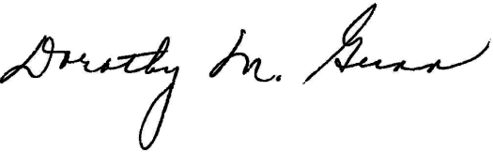
Dorothy M. Gunn, Clerk
Illinois Pollution Control Board

